This guide consists of three parts:

1. Making an Open Science Framework Account (OSF)
2. Creating a space that you can use the guides and do your homework
3. Using RollApp with your OSF account

**How to Make an OSF Account:**

The Open Science Framework (OSF) is a website devoted to open science materials. We have shared all of our JASP guides and datasets on this website. You can use our shared materials and create your own on this website, which you can link to the online version of JASP.

To create an OSF Account, you will first need to go to:

[https://osf.io/](https://osf.io/%20)

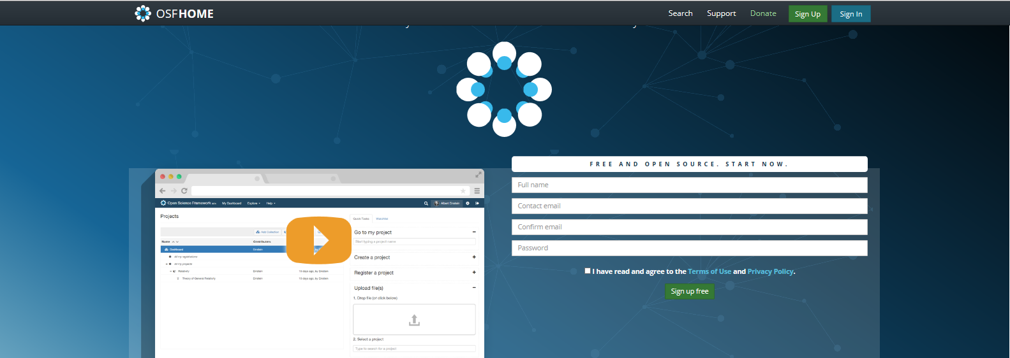

Click the Sign Up button  in the top right hand corner of the webpage and fill in your information in the “Create a free account” window.

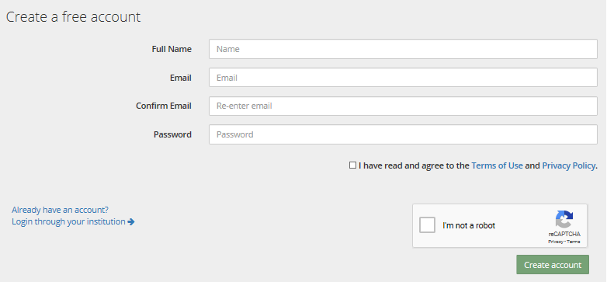

Click the box next to “I have read and agree to the Terms of Use and Privacy Policy” once you have reviewed the documents.

Next, click the box next to “I’m not a robot” and then click .

You will then receive a confirmation email with a link to verify your OSF account. Once you click on the link you will have successfully created your account.

For a more detailed How to Guide click on the link below to access the Create an OSF Account through the OSF Help Guides page.

[http://help.osf.io/m/account/l/696112-create-an-osf-account](http://help.osf.io/m/account/l/696112-create-an-osf-account%20)

**How to Make an OSF Page for your own use:**

In this section, you will “fork” our project, which means that you will make your own copy of our page. From this copy, you will be able to open and edit the guides/datasets, as well as upload your own work to do your homework.

Go to our OSF page: <https://osf.io/t56kg/>

Click on the Fork Icon (the number may be different): 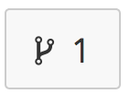

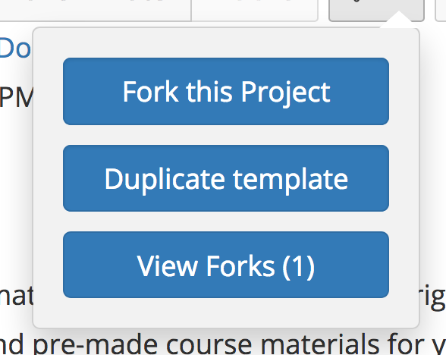

Click fork this project.

You’ll see this message after you complete the fork:

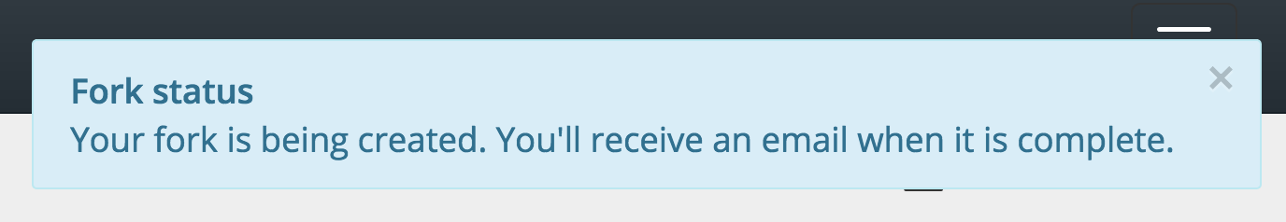

When you go to your OSF homepage, you should see the Fork.



Click on that link.

You should now see your own version of the original OSF page.

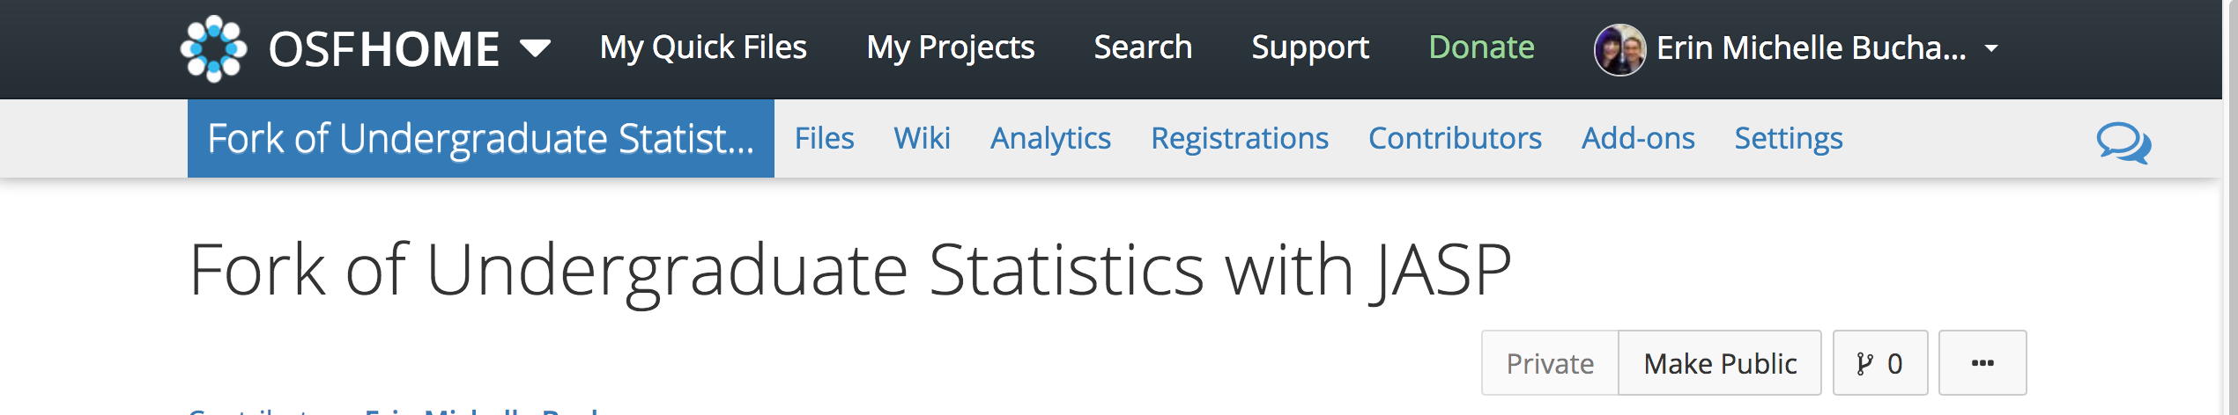

Any changes you make will only affect your version (so you aren’t editing ours!). At the top right you will see Make Public. 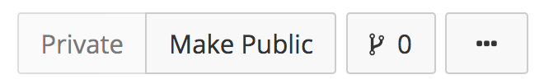

You want to leave this alone – the Private option is grayed out because the Fork page is currently private. Since you will do your homework this way, you can leave it private to not share your homework.

How to add homework files and other information to use in JASP:

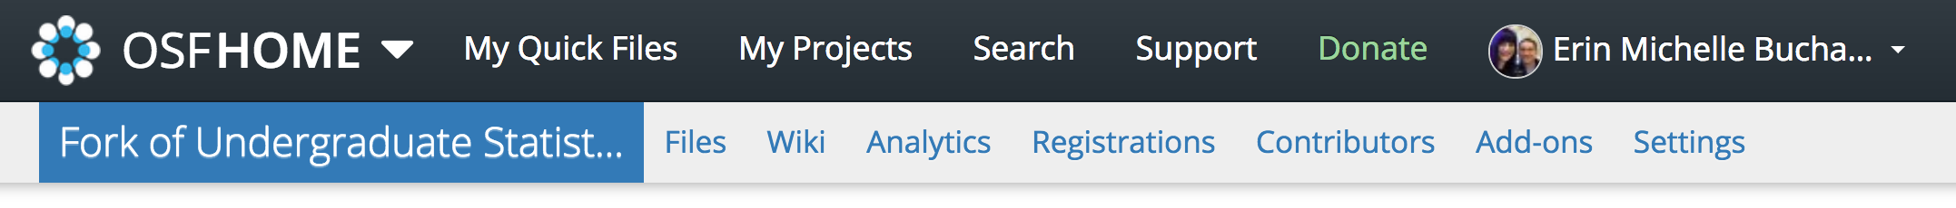

Click on Files.

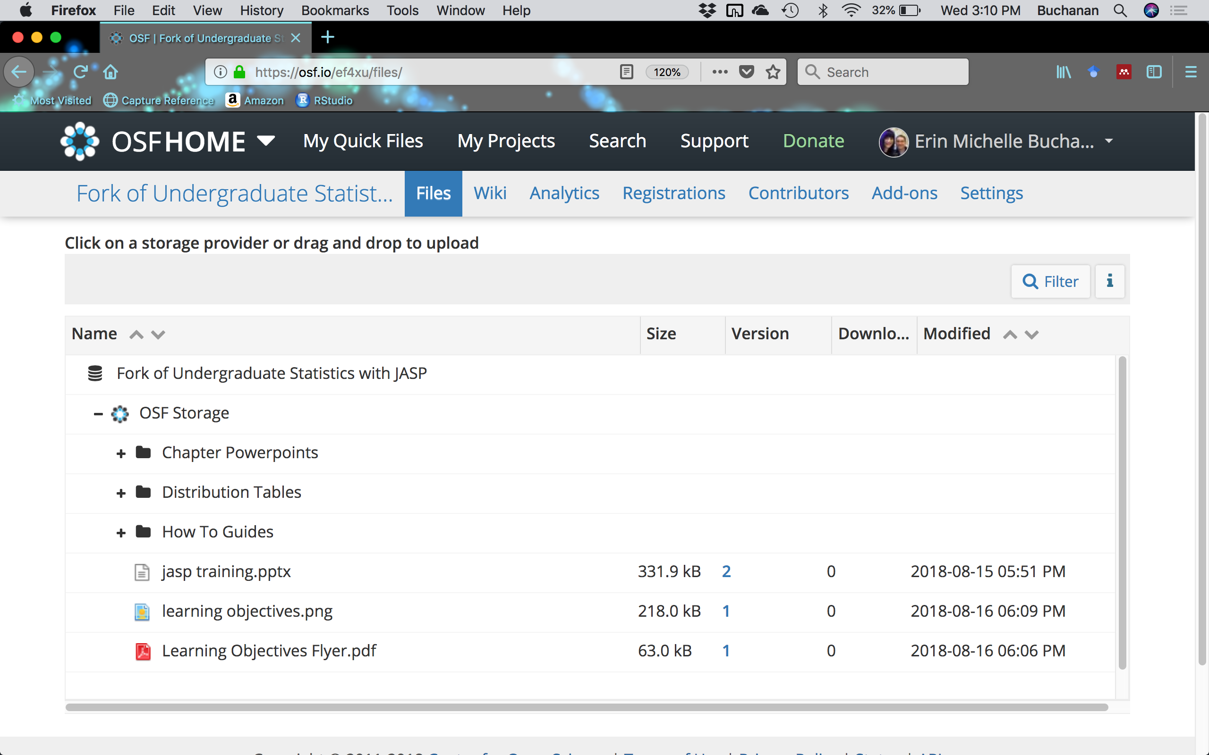

On this page, you can see the how to guides and other information that has been copied over from our page. If you click OSF Storage ­, you will see more options.

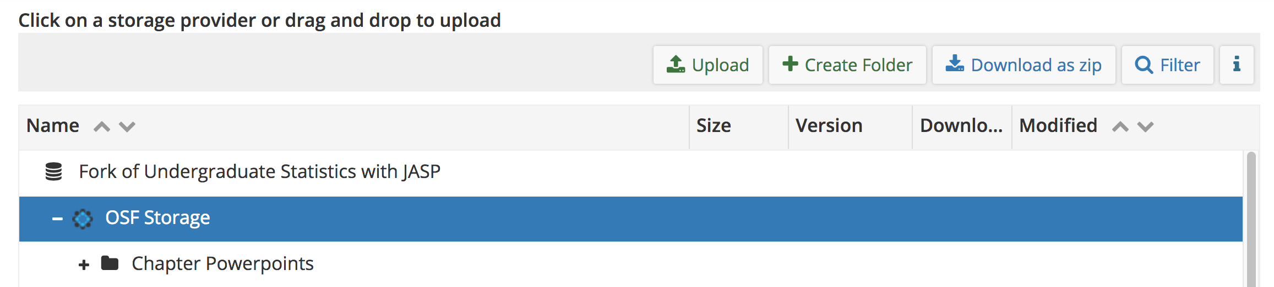

Now you can create folders for homework or however you want to organize your work. If you get a .csv from your instructor for your homework, you can upload it here. Also, any work saved from JASP will also be stored in this area.

**Opening JASP in your Browser:**

To get started using JASP, you will first need to go to:

<https://jasp-stats.org/>



Click the download JASP button. 

Click the  button under “Run JASP in your Browser”. JASP will then open in a pop-up window.

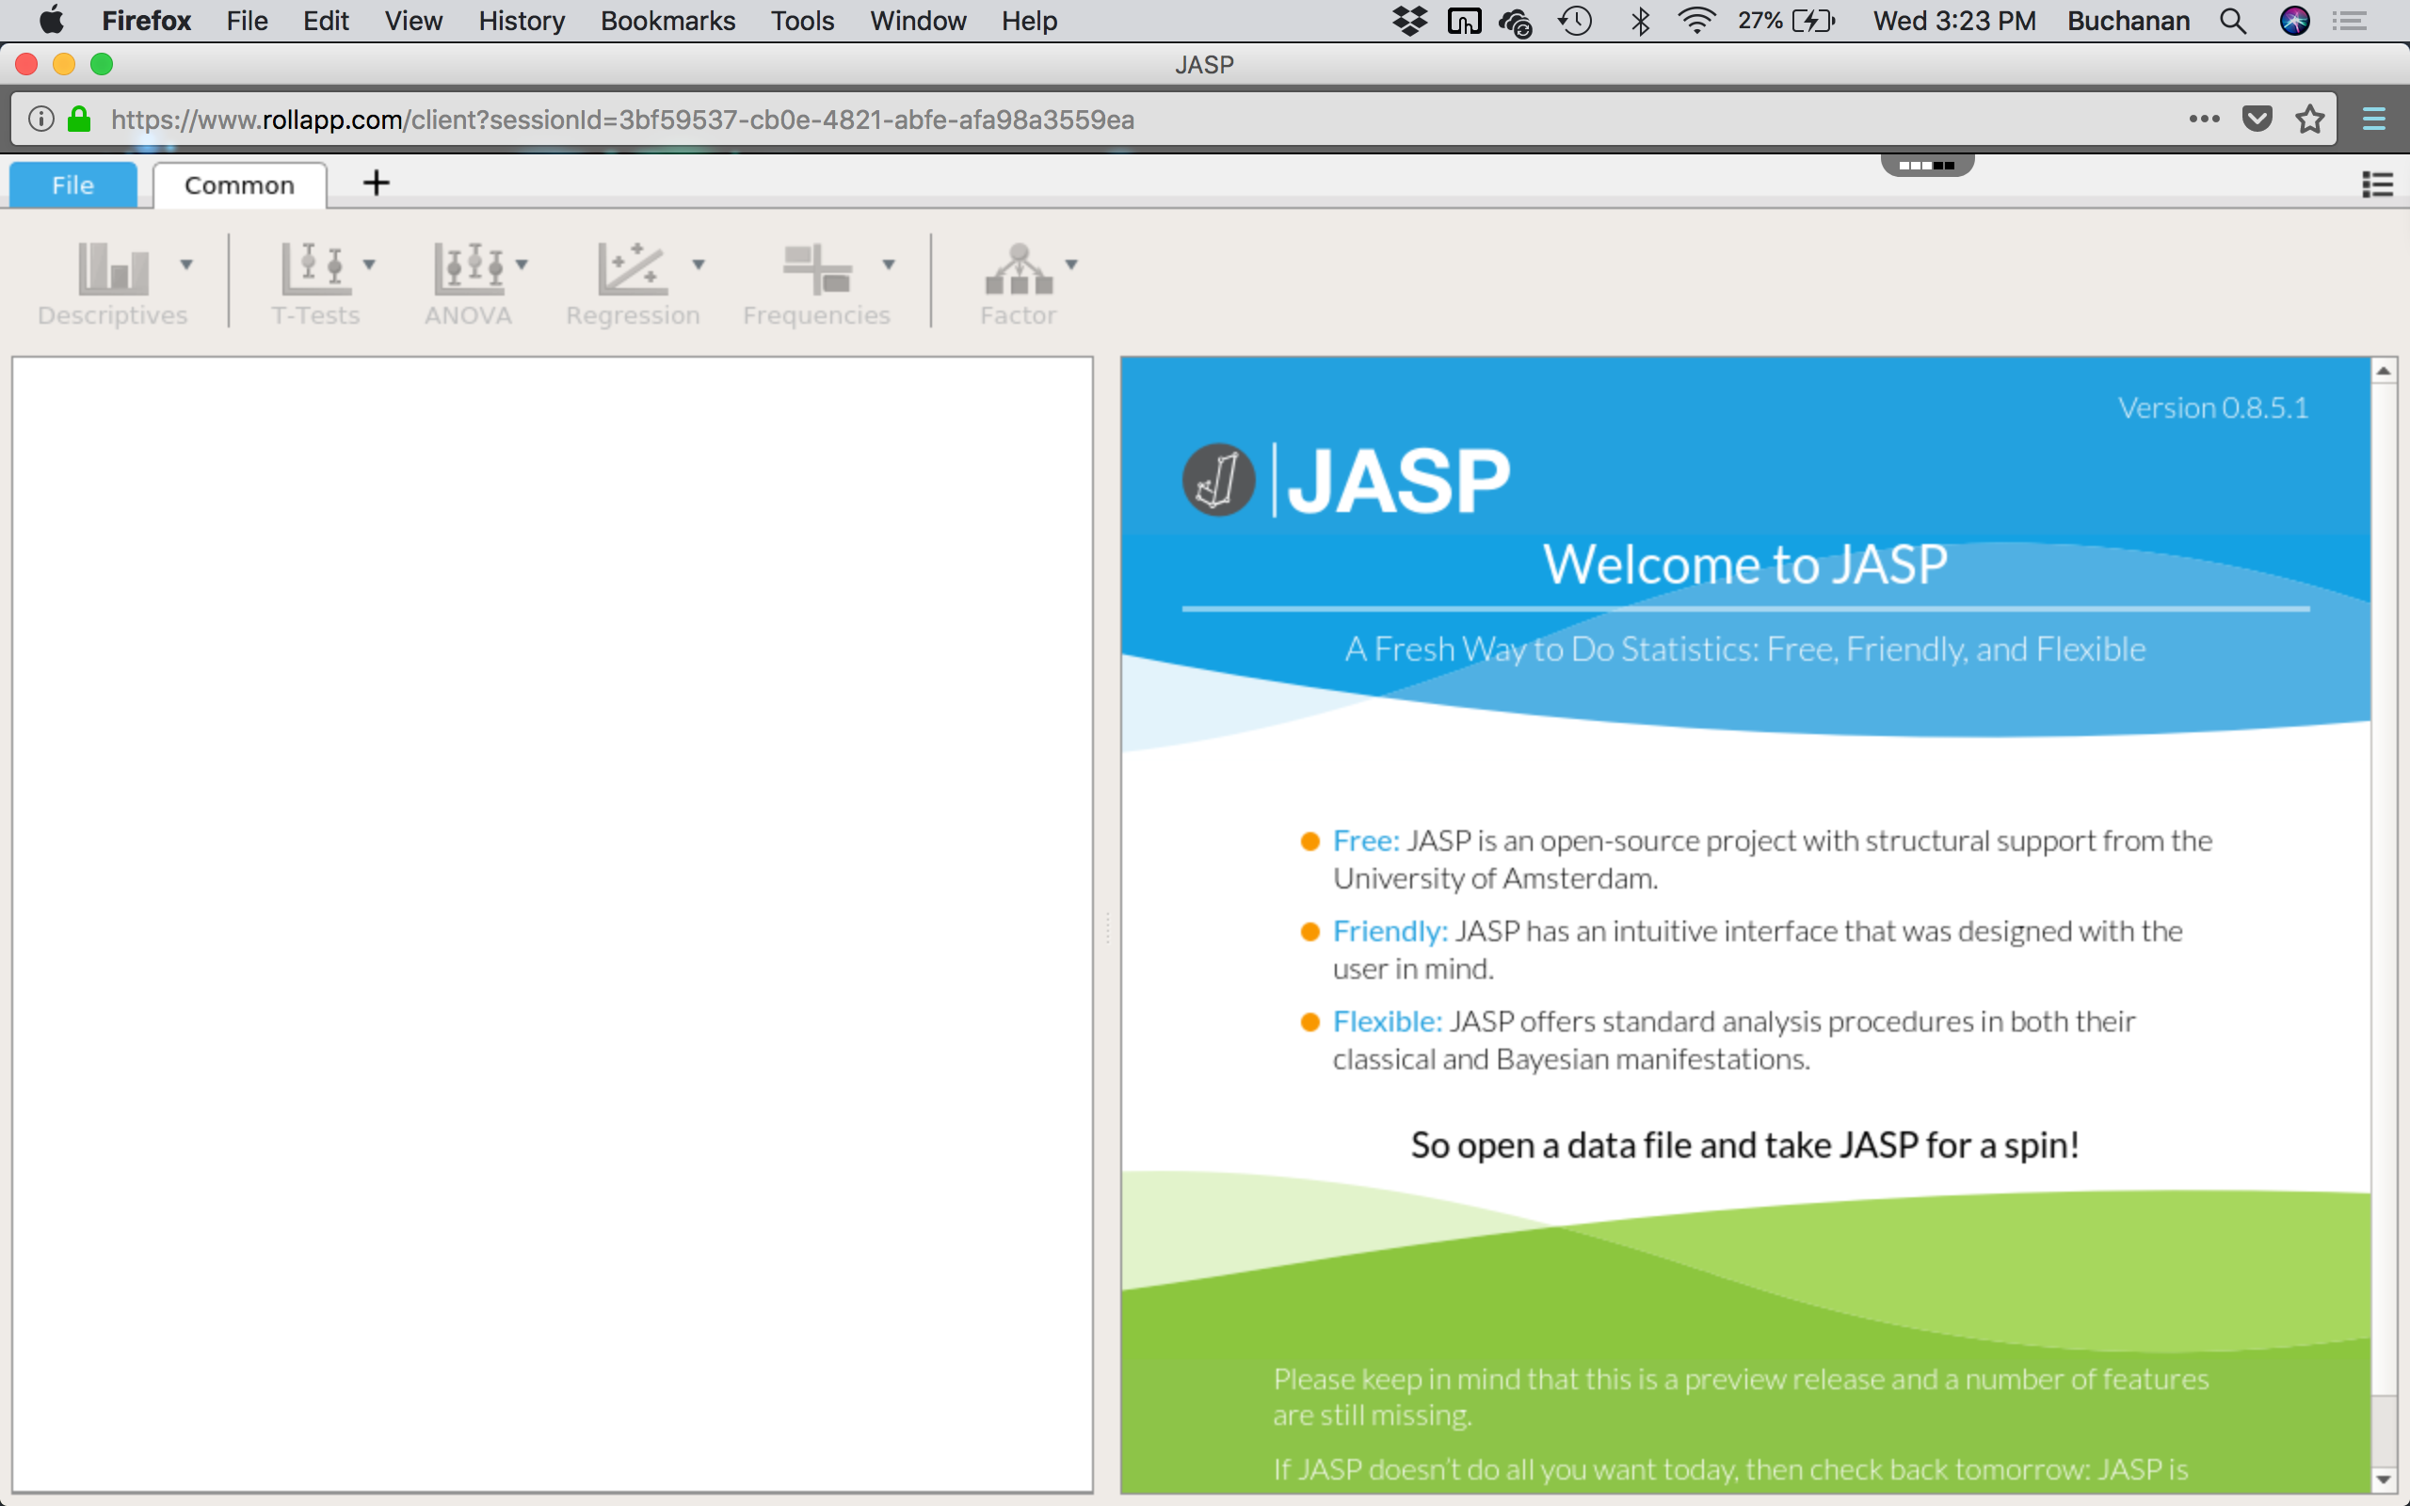

Click File to get started.

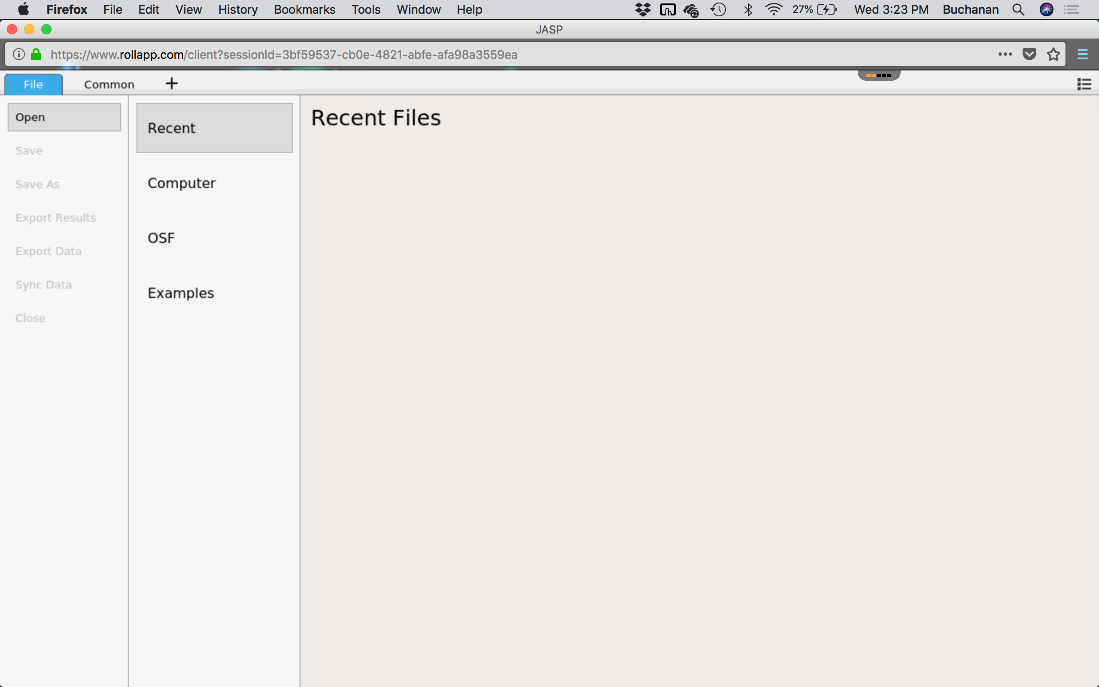

Click OSF to log into your new account.

